# Exercise -1

Implementing the Singleton Pattern :

1. Lazy Method:

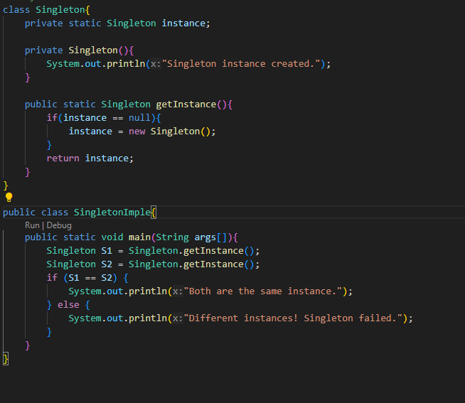

Output:



2.Eager Mathod:

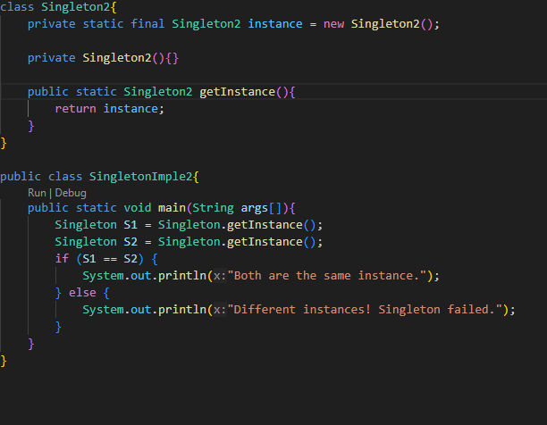

Output:

